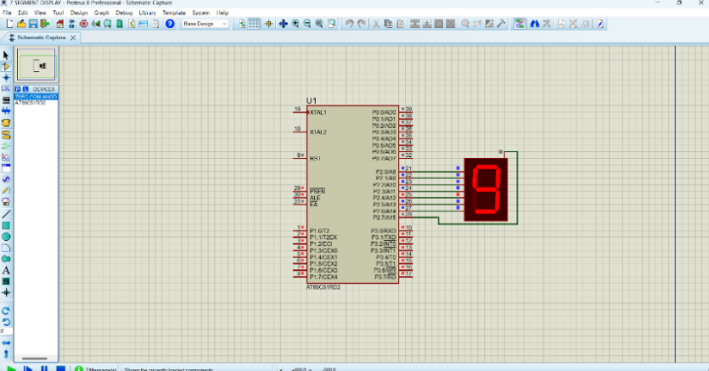
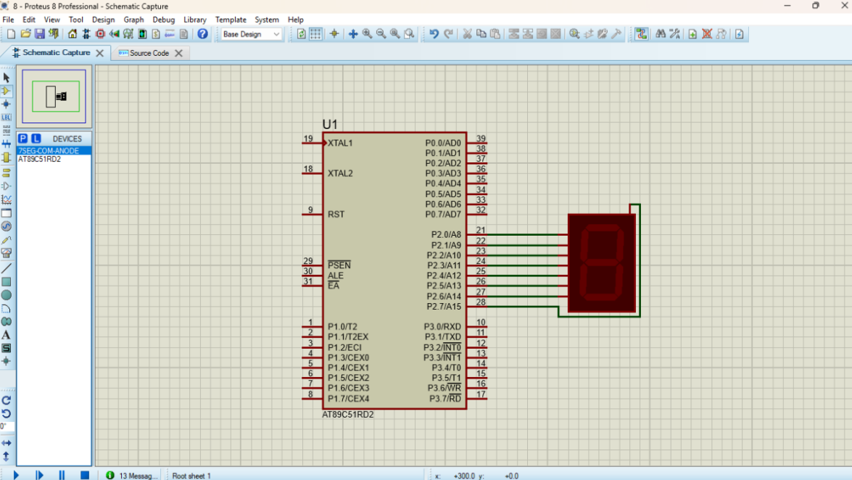
7 SEGMENT DISPLAY USING AT89C51 USING PROTEUS

